Whitewater Rafting Site Plan

Logo
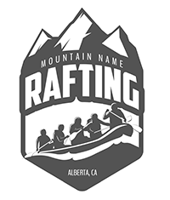

Style Guide
Color Pallette URL: https://coolors.co/437c90-255957-eeebd3-a98743
- primary-color #437C90
- secondary-color #255957
- accent1-color #EEEBD3
- accent2-color #A98743

Font Labels
Headings: Arvo, Regular 400, White
Body: Protest Revolution, Regular 400, White

